Turn in one lab report per group of two. Change the title of the lab to include the last names of each person -- “Smith, Jones - Speed of Sound Lab” Share the lab with each other and the instructor BEFORE you start the lab. Each person should complete about 50% of the lab write up. Delete everything in red before the due date.
Sound Waves and Beats Lab
Names:
Period:
Date:
Background from Vernier Physics Lab Book:
Sound waves consist of a series of air pressure variations. A Microphone diaphragm records these variations by moving in response to the pressure changes. The diaphragm motion is then converted to an electrical signal. Using a Microphone and an interface, you can explore the properties of common sounds.
The first property you will measure is the period, or the time for one complete cycle of repetition. Since period is a time measurement, it is usually written as T. The reciprocal of the period (1/T) is called the frequency, f, the number of complete cycles per second. Frequency is measured in hertz (Hz). 1 Hz = 1 s–1.
A second property of sound is the amplitude. As the pressure varies, it goes above and below the average pressure in the room. The maximum variation above or below the pressure mid-point is called the amplitude. The amplitude of a sound is closely related to its loudness.
In analyzing your data, you will see how well a sine function model fits the data. The displacement of the particles in the medium carrying a periodic wave can be modeled with a sinusoidal function: . y = Asin(2$π$𝒇 𝘵 )
In the case of sound, a longitudinal wave, y refers to the change in air pressure that makes up the wave, A is the amplitude of the wave, and f is the frequency. Time is represented by t, and the sine function requires a factor of 2π when evaluated in radians.
When two sound waves overlap, air pressure variations will combine. For sound waves, this combination is additive. We say that sound follows the principle of linear superposition. Beats are an example of superposition. Two sounds of nearly the same frequency will create a distinctive variation of sound amplitude, which we call beats.
BACKGROUND SUMMARY:
Read all of the background information and have each lab partner record one interesting fact that you learned about. Be specific. Use complete sentences. Do not copy word for word. Ex: 3 lab partners = 3 facts, not the same

OBJECTIVES
- Measure the frequency and period of sound waves
- Measure the amplitude of sound waves
- Observe beats between the sounds of two notes from a keyboard.
MATERIALS
computer | Vernier Microphone
Vernier computer interface  Logger Pro | electronic keyboard (or app)

PROCEDURE and DATA
Part I Simple Waveforms
- Connect the microphone to the labquest mini and connect the labquest mini to the computer.
- Open the file “32 Sound Waves” in the Physics with Vernier folder on the computer. Data are collected for only 0.05 s in order to be able to display the rapid pressure variations of sound waves. The vertical axis corresponds to the variation in air pressure and the units are arbitrary so you amplitude will not have units.
- To center the waveform on zero, it is necessary to zero the Microphone channel. When the room is quiet, zero the instrument by selecting the “experiment” tab and then “zero” to center waveforms on the time axis.
- Find a tone generator that will produce a pure tone around 523Hz. (click here for an online version)
Actual Frequency of note played: _____
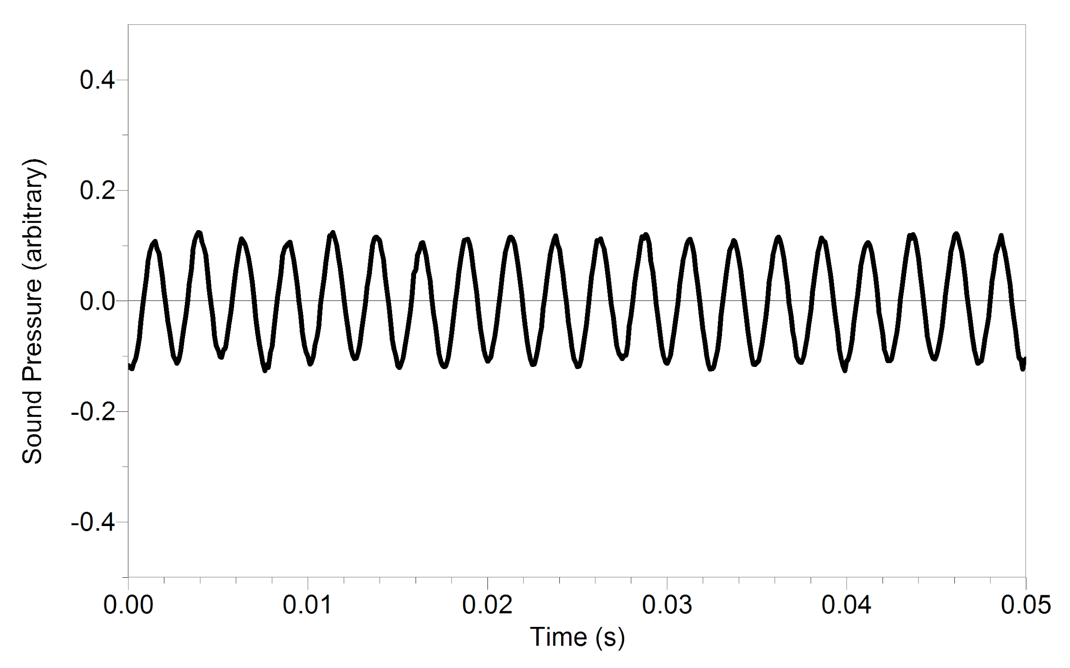
- Play the selected tone. Hold the Microphone close to the speaker and click . The data should resemble a sine wave. If you do not see a sine wave try setting the zero point again (previous step) or increase the volume. Select the “experiment” tab and then select “autoscale” to see the curve easier. The shape should look similar to the picture shown to the right:

- Take a picture of your graph and paste it below:
- Simultaneously press the CTRL key and the E key to examine the graph. Click on the crest of the first full peak. While holding the bottom left area of the mouse pad, drag the cursor across the screen so that it includes at least 10 full wavelengths and stop at the crest of the wave. Determine the frequency of the waveform in cycles/sec. (To determine the number of cycles, count the number of peaks in the shaded area after the first peak. To determine the time, look at the bottom of the screen to see Δt.)
Calculated frequency = (cycles/sec) = cycles ___ / Δt = ____ = _________
Determine the experimental error between the actual frequency from step 4 and the calculated frequency in step 8?
(experimental error = (actual value - experimental value)/actual value
Frequency Experimental Error _______
What could have caused this error? ______
- Determine amplitude of the waveform by clicking and dragging the mouse on the graph from the crest to the trough of the wave. Read the difference in y values, shown at the bottom left of the graph as Δy. In this case, the value will not have units because the y axis is only relative arbitrary units for pressure. Δy = __
- Calculate the amplitude of the wave by dividing Δy by 2. In this case, the amplitude will not have units because the y axis is only relative arbitrary units for pressure.
Calculated Amplitude: _______
- The following steps will allow you to autofit your data to a sine function y = A * sin(B*t + C) + D This function is more complicated than the equation given in the background, but the basic sinusoidal form is the same.
  - Select the “analyze” tab and then select “curve fit”
  - In “general equation” box scroll down to select y = A * sin(B*t + C) + D
  - Under the heading “type of fit” select “automatic.” Click the “try fit” button

- Enter the numbers from the curve fit data and compare to your experimental calculated values. Note: The parameters C and D shift the fitted function left-right and up-down, respectively, and are used to obtain a good fit
 | Curve Fit Data | Experimental Data
A (amplitude)
B=2𝞹(calculated frequency)
C |  | not applicable
D |  | not applicable
Correlation |  | not applicable

- How well do your values compare to the curve fit data? Based on the correlation value, is this a good function to fit the data?Since the model parameter B =2π f , use your curve fitted model to determine the frequency of the wave: f = B/2𝞹 = __
Compare this frequency to the frequency calculated in #6. Which would you expect to be more accurate? __ Why? __
Part II Beats
- Change the data collection time to 1 second by completing the following steps:
  - Select the “experiment” tab and select “data collection”
  - Change the collection duration to 1 sec

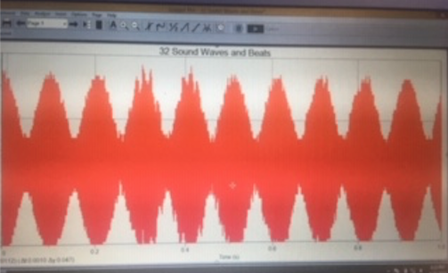
- Two pure tones with different frequencies sounded at once will create the phenomenon known as beats. Sometimes the waves will reinforce one another and other times they will combine to a reduced intensity. To observe beats, play one tone at 450Hz and another tone at 440Hz simultaneously. Listen for the combined sound, you should be able to hear a variation in intensity. What is the frequency of the beat that you should hear based on the difference of the two frequencies? __

- Collect data while the two tones are sounding. You should see a wave that looks similar to this:

- Take a picture of your graph and paste it below:

- Determine the frequency of the combined wave in cycles per second: __

- What is the percent difference between the expected frequency in step 13 compared to the experimental frequency in step 16?

percent difference = (expected value - experimental value)/expected value = __

What could cause this difference? ___

Summary

Summarize what you learned in each section using complete sentences and data.

